# Exercises: Integration Testing

Problems for exercises and homework for the [“Java Web Development Basics” course @ SoftUni](https://softuni.bg/courses/java-web-development-basics). Submit your solutions on the **course page** of the **current instance**.

# Car Dealer

Car Dealer is an application for cars and car parts sales accounting. It manages customers, cars, parts, suppliers and sales. You have been given the infrastructure of the back-end – entities, repositories, services, configuration etc.

You will also be given a simple documentation of the application.

# Documentation

## Database Documentation

The database of the Car Dealer application supports 5 entities:

### Customer

* Has a Id – a **UUID string**
* Has a Name – a **string**
* Has a Birth Date – a LocalDate object
* Has a Is Young Driver – a **boolean**

### Car

* Has a Id – a **UUID string**
* Has a Make – a **string**
* Has a Model – a **string**
* Has a Travelled Distance – a **64-bit integer**
* Has Parts – a **collection** of Part objects

### Supplier

* Has a Id – a **UUID string**
* Has a Name – a **string**
* Has a Is Importer – a **boolean**

### Part

* Has a Id – a **UUID string**.
* Has a Name – a **string**
* Has a Price – a BigDecimal object
* Has a Supplier – a Supplierobject**.**

### Car Sale

* Has a Id – a **UUID string**.
* Has a Discount – a **floating-point** (percentage)
* Has a Customer – a Customer object
* Has a Car – a Carobject**.**

### Car Sale

* Has a Id – a **UUID string**.
* Has a Discount – a **floating-point** (percentage)
* Has a Customer – a Customer object
* Has a Part – a Partobject**.**
* Has a Quantity – a **32-bit integer**.

Here is a database schema:

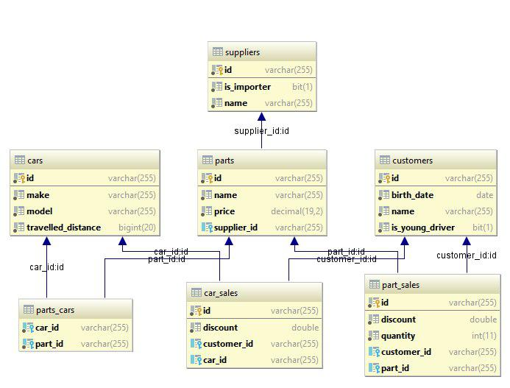

## Functionality Documentation

The functionality is:

User:

* Register
* Login
* Logout

Customer:

* Add customer
* List all customers

Car:

* Add car
* Edit car
* Delete car
* List all cars

Supplier:

* Add supplier
* Edit supplier
* Delete supplier
* List all suppliers

Part:

* Add part
* Edit part
* Delete part
* List all parts

# Integration Testing

You have been tasked to perform Integration testing on the **Web Layer** of the Car Dealer application. Test all methods with all possible cases you can think of.